**LAB 2C**

Part1: Create and Terminate EC2 Instance Using AWS CLI

Step1: Create an EC2 Instance Using AWS CLI

InstanceId": "i-0188da08c57692357"

Step2: Verify the Running Instance

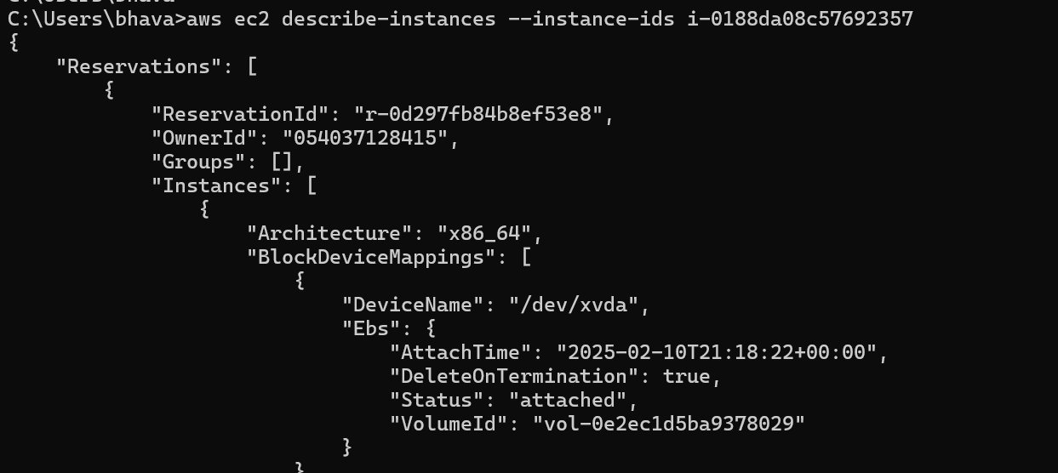

Step3:Terminate the EC2 Instance Using AWS CLI

Part2: Create and Terminate EC2 Instance Using Python Boto3

Step1: Create an EC2 Instance Using Python Boto3

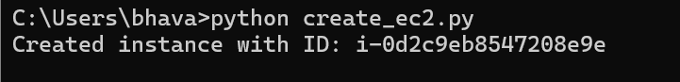

Instance ID: i-0d2c9eb8547208e9e

Step2:Terminate EC2 Instance Using Python Boto3

Step3: Verification and Cleanup

**Challenges Faced:**

While creating an EC2 Instance Using Python Boto3, I did not create the key pair first so I had an error, then I created the key pair and program ran successfully.